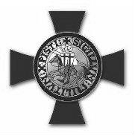

Grand Commandery of Knights Templar of Washington

CHRISTMAS SERVICE OBSERVANCE

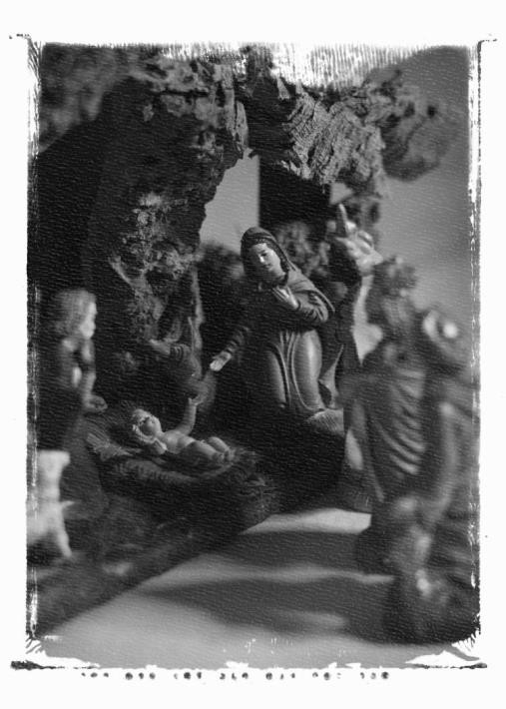

FOREWORD

Sir Knights

The Constituent Commanderies, since its foundation, have celebrated Christmas as it is the birth of our Lord and Savior and due to uniqueness of our fraternal organization. I have seen throughout this and other jurisdictions different ways the Christmas Observance has been celebrated. There are two ways that stand out.

1) Triangle
All the Ladies and guests are assembled in the Asylum. The Sir Knights marched in with the appropriate processional music. Twelve Sir Knights gather around the triangle to give the mandatory toasts. Ladies and guests join in the prayers and toasts from the sidelines.

2) Table
All Sir Knights, Ladies and guests gather at a table which is in the form of a cross and located inside the Asylum. All present give the mandatory toasts. This style gave a
sense of community and inclusiveness to the Observance.

As this is a public event, each Commandery may select any of the above ways to celebrate your Christmas Observance. This will be a decision of the Constituent Commandery or, if time does not permit, the Eminent Commander. The most important point of this event is to make everyone that attends feel they are a part of our celebration and community. Make the Ladies and guests active participants in the celebration, prayers and mandatory toasts. We accomplish this by having everyone in the Asylum sing along, pray, and have the toasts with us.

We highly encourage and recommend the Commandery publish a small booklet with the songs and prayers be printed for the Sir Knights and Guests. Also, many Sir Knights, Ladies and guests do not drink wine, please have some sparkling grape juice, grape juice or other substitute available.

“O COME, O COME EMMANUEL IS ESPECIALLY APPROPRIATE FOR PROCESSIONALS.

If the Commandery is using the triangle, it is a very effective procedure to place the triangle with candles, goblets and other items in the center and have the twelve Sir Knights who would normally be in those positions remain so while the other Sir Knights seat themselves among the guests.

Glasses or goblets should be provided for all Sir Knights. Paper cups or cups can be provided to all visitors present so that they also might participate in the Toasts.

If the Commandery so wishes to have a more effective family or community format, they may use tables in the form of the Cross (please see diagram in the Appendix) and have all Sir Knights and Guests sit at the table to join in the festivities. This can be used in the Asylum. Please make sure guests are at the table prior to the Sir Knights entering the Asylum.

The Eminent Commander may allow the Sir Knights not to kneel depending on their age or condition. If one Sir Knight cannot kneel, it will look better that all remain standing.

If the Commandery is having a Christmas dinner, this should be done prior to the Observance in the dining hall.
IF USING THE TRIANGLE FORMAT - PROCESSIONAL: (GUESTS ARISE, REMAIN STANDING FOR PROCESSIONAL) PARTICIPATING SIR KNIGHTS ENTER THE ROOM TO THE SOUNDS OF BACKGROUND MUSIC AS DESIRED. NO SINGING. PROCEED IN SILENTLY.

• All remain standing and sing opening Christmas carols: “Oh Come, all the Faithful” and
“The first Noel”.

IF USING THE TABLE FORMAT – NO PROCESSIONAL, EMINENT COMMANDER WILL ASK ALL TO RISE.

EMINENT COMMANDER – Sir Knights, Ladies and Guests, please rise and
join me in singing “O Come All Ye Faithful” and “The First Noel”.

O COME ALL YE F AITHFUL
O come, all ye faithful, joyful and triumphant
O come ye, O come ye to Bethlehem;
Come and behold him, born the King of Angels, O come let us adore Him,
O come let us adore him,
O come let us adore him, Christ
The Lord.
THE FIRST NOEL
The first noel the angel did say Was to certain poor shepherds In fields as they lay;
In fields where they lay
Keeping their sheep,
On a cold winter’s night That was so deep; Noel, Noel, Noel, Noel Born is the King of Israel.

(All are seated after singing the opening Christmas Carols)

EMINENT COMMANDER: Sir Knights, Ladies and Guests, be seated.

WELCOMING ADDRESS: (by EMINENT COMMANDER)

EMINENT COMMANDER: Sir Knights, Ladies and Guests, rise. Sir Knights, uncover.
Excellent Prelate, lead us in prayer.

INVOCATION (OPENING PRAYER): (by PRELATE)

EMINENT COMMANDER: Sir Knights, recover. S.K. leads us in the Pledge of Allegiance.

PLEDGE OF ALLEGIANCE: S/K___________________

EMINENT COMMANDER: Sir Knights, Ladies and Guests, be seated.

EMINENT COMMANDER: Excellent Prelate, please read the old story.
PRELATE: Sir Knights, Ladies and Guests, once I finish each reading, please repeat the words
GLORY BE TO GOD IN THE HIGHEST after me.

ISAIAH 11: 1-5
And there shall come forth a rod out of the stem of Jesse, and a branch shall grow out of his roots. And the spirit of the Lord shall rest upon him, the spirit of wisdom and understanding, the spirit of counsel and might, the spirit of knowledge and of the fear of the Lord; and shall make him of quick understanding in the fear of the Lord; and he shall not judge after the sight of his eyes, neither reprove after the hearing of his ears;

But with righteousness shall he judge the poor, and reprove with equity for the meek of the earth; and he shall smite the earth with the rod of his mouth, and with the breath of his lips shall he slay the wicked. And righteousness shall be the girdle of his loins and faithfulness the girdle of his reins.

Audience Response: GLORY BE TO GOD IN THE HIGHEST!

LUKE 2:1-14 And it came to pass in those days that there went out a decree from Caesar Augustus that all the world should be taxed. (And this taxing was first made when Cyrenius was Governor of Syria.) and all went to be taxed, every one into his own city. And Joseph also went up from Galilee, out of the city of Nazareth, into Judea, unto the city of David, which is called Bethlehem (because he was of the house and lineage of David.) To be taxed with Mary his espoused wife, being great with child. And so it was, that while they were there, the days were accomplished that she should be delivered. And she brought forth her first born son, and wrapped him in swaddling clothes, and laid him in a manger; because there was no room for them in the inn.

And there were in the same country shepherds abiding in the field, keeping watch over their flock by night. And lo, the angel of the Lord came upon them, and the glory of the Lord shone round about them, and they were sore afraid. And the angel said unto them, Fear not; for behold, I bring you good tidings of great joy, which shall be to all people. For unto you is born this day in the city
of David a Savior which is Christ the Lord. ***And suddenly there was with the angel a multitude of the heavenly host praising God, and saying Glory to God in the Highest, and on earth peace, good will toward men.

Audience Response: GLORY BE TO GOD IN THE HIGHEST!

EMINENT COMMANDER: Sir Knights, Ladies and Guest, please rise. Excellent
Prelate, please lead us in singing “Silent Night.”

(All stand and sing two verses of “Silent Night” as given in the program.)

SILENT NIGHT
Verse 2
Silent Night, Holy Night
Wondrous star, lend thy light!
with the angels let us sing Alleluia to our King:
Christ the Savior is born
Christ the Savior is born

Verse 1
Silent Night, Holy Night
All is calm, All is bright
Round Yon virgin mother and child.
Holy Infant so tender and mild,
Sleep in heavenly peace
Sleep in heavenly peace.

EMINENT COMMANDER – Sir Knights, Ladies and Guests, be seated.

STATEMENT - EMINENT COMMANDER:

Sir Knights and guests, on this glorious occasion we commemorate the birth of Jesus of Nazareth. Emmanuel, “God with us”, is the foundational truth of the season. Scholars debate the actual date of his birth; local residents of the area of Bethlehem have a traditional site affixed; but, our primary focus; indeed, our only focus, is the reality that Jesus was, in fact, born in the flesh, sent by God the Father to become as the Son of God a Man for our salvation. The Great Captain under whose banner we have all enlisted and in whose name we battle.

The reality is that over two thousand years ago, a child was born in Bethlehem of Judea. One with divine attributes but who assumed mortal flesh; one whose glory, worth and grace no language can express and no word can quantify; one who was born that our lives might be purified, and who died and shed his blood so that we might be free of the penalty, power and the future presence of sin. Let us, as true Soldiers of the Cross, strive to profit by the birth, life, death, resurrection and ascension of that Divine Master, and remain his faithful soldiers unto death. Seeking strength to continue that struggle, let us now accompany our Excellent Prelate to the throne of heavenly grace. Excellent Prelate, lead our devotions.

Sir Knights, ATTENTION. **Kneel (the Commander may have the Sir Knights remain standing, if many can’t kneel). ** Ladies and Guests please rise and join us in our devotions.

(Sir Knights uncover on orders, Kneel on left knee (**Commander may have everyone remain standing**)
and bow their heads.)
PRAYERS

(AFTER EACH PRAYER, SIR KNIGHTS AND GUESTS WILL REPLY “A MEN ” )

PRELATE: Almighty and most merciful Father, remember us with Your Grace, we humbly request, and blot out the multitude of our transgressions for Your Beloved Son’s sake. And may the words of our mouths and the meditations of our hearts be acceptable in Your sight, through Jesus Christ our Lord.

RESPONSE: Amen!

PRELATE: Father in heaven, command Your blessings to rest upon all true Knights of the Temple wherever dispersed; bestow upon them a spirit of Truth, Justice, Courage, Constancy, Faith and Humility, and make of them valiant defenders of Your holy religion. Teach them to feed the hungry, clothe the naked and bind up the wounds of the afflicted for Jesus’ sake.

RESPONSE: Amen!

PRELATE: O Lord, command Your benediction to rest upon our Grand Master. Help him to rule over us in love, and with an eye single to Your glory. Keep and save him from error, prejudice, and pride and give him firmness of purpose to do what is right for Christ’s sake.

RESPONSE: Amen!

PRELATE: Our Father, let Your choicest blessings be with the President of the United States, our Governor and all those in positions of authority. Endue them with wisdom on high, and may it be their highest joy to labor for Your glory and power alone, and for the good of the people for whom they legislate, and over whom they rule. W e ask this in the name of our Lord and Savior, Jesus Christ, Emmanuel.

RESPONSE: Amen!

EMINENT COMMANDER - **Sir Knights, arise (if kneeling). ** Sir Knights, recover.
Sir Knights, Ladies and Guest, be seated.

Before the toast, if the Commandery has any Grand Commandery Line Officers or Past Grand Commanders in their Observance, the Eminent Commander should introduce them and ask if they have a short message for the Sir Knights and guests. If the Eminent Commander invited a minister or a Grand Line officer to give a Christmas Message, it is appropriate to do so after the introductions of dignitaries.

+++++++++++++++++++++++++++++++++++++++++++++++++++++++++++++++++++++++++++++++++++++++++++

(Use if using the Triangle format)

EMINENT COMMANDER: Let the chosen twelve gather around the triangle.

EMINENT COMMANDER: Let the libations be poured** into the goblets on the Triangle and
The Pedestal. (DONE)

Let every Knight and Guest be furnished with a prepared goblet. (DONE)

*** (Let the Senior and Junior Wardens or the recent knighted Sir Knights to serve the wine) ***

+++++++++++++++++++++++++++++++++++++++++++++++++++++++++++++++++++++++++++++++++++++++++++

(Use if using a Table format)

Eminent Commander: Let the libations be poured** into the goblets (or glasses) on the table. (DONE)

Let every Knight and Guest be furnished with a prepared goblet. (DONE)

*** (Let the Senior and Junior Wardens or the recent knighted Sir Knights to serve the wine) ***

+++++++++++++++++++++++++++++++++++++++++++++++++++++++++++++++++++++++++++++++++++++++++++
Toast No. 1

EMINENT COMMANDER: Sir Knights, Ladies and Guest, please rise! Sir Knight
, read the toast to our Grand Master of Knights Templar, Sir Knight __________________.

SIR KNIGHT : (Reads the toast as supplied to Commanderies)

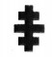

THE APARTMENTS OF THE GRAND PRELATE
AND THE COMMITTEE ON RELIGIOUS ACTIVITIES

Note: The toast from the Grand Prelate of the Grand Encampment will not be added to this document as it depends when the Grand Encampment send it out to the Grand Commanderies and Constituent Commanderies. Please contact the Grand Recorder of the Grand Commandery of Washington or see if it has been posted on the Grand Encampment’s website.

EMINENT COMMANDER: To our Most Eminent Grand Master, Sir Knight ________________!

SIR KNIGHTS: To our Most Eminent Grand Master!

EMINENT COMMANDER: Partake!

EMINENT COMMANDER: Sir Knights, Ladies and Guest, be seated. Sir Knight ____________, read the Grand Master’s response.

Sir Knight (The Sir Knight stands up and reads the response)

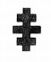
GRAND MASTER'S RESPONSE

Note: The reply from the Grand Master will not be added to this document as it depends when the Grand Encampment send it out to the Grand Commanderies and Constituent Commanderies. Please contact the Grand Recorder of the Grand Commandery of Washington or see if it has been posted on the Grand Encampment’s website.

Toast No. 2
EMINENT COMMANDER: Sir Knights, Ladies and guest, rise!
Sir Knight ______________ read the Grand Prelate’s toast to the Right Eminent Grand Commander of Knights Templar of Washington, Sir Knight ___________.

SIR KNIGHT : (Stands and reads the Toast)
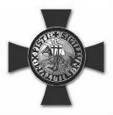

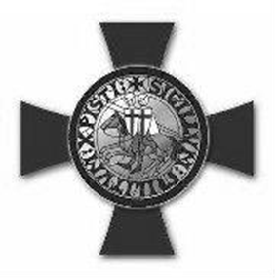

GRAND PRELATE’S TOAST TO THE RIGHT EMINENT GRAND COMMANDER

(Insert Toast of the Grand Prelate)

EMINENT COMMANDER: To our Right Eminent Grand Commander, Sir Knight. !

SIR KNIGHTS: (REPEAT) To our Right Eminent Grand Commander!

EMINENT COMMANDER: Partake!

EMINENT COMMANDER: Sir Knights, Ladies and Guests, be seated.

Sir Knight ____________________, read the Right Eminent Grand Commander’s response to the Toast of the Eminent Grand Prelate.

SIR KNIGHT : (Sir Knight stands and reads the response)

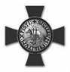
GRAND COMMANDER’S RESPONSE

(INSERT REPONSE OF GRAND COMMANDER)

TOAST No. 3

EMINENT COMMANDER: To all Knights Templar, wheresoever dispersed!

SIR KNIGHTS (Repeat after Commander): To all Knights Templar wheresoever dispersed!

EMINENT COMMANDER: Partake!

TOAST No. 4

EMINENT COMMANDER: To all Knights Templar who have shed their blood in defense of Liberty and Christianity. (Commander doesn’t lift his goblets as there is no drinking with this toast).

SIR KNIGHTS (Repeat after Commander): To all Knights Templar who have shed their blood in defense of Liberty and Christianity. (All then bow their heads in silence, NO drinking.)

TOAST No. 5

SIR KNIGHT : To the Grand Master of Masons of Washington, Most Worshipful ______________________!

SIR KNIGHTS (repeat): To the Grand Master of Masons of Washington!

EMINENT COMMANDER: Partake!

TOAST No. 6

EMINENT COMMANDER: Let us recall the hallowed memories of the Fraters of our own jurisdiction who have joined the silent majority. Sir Knight Recorder, please read the
names of those that this year have joined the Celestial Conclave above. (If no one passed away this year, omit the request to the Recorder.)

(The Twelve Knights will place their goblets on the triangle or table)

EMINENT COMMANDER: In memory of the dead of this jurisdiction during this Year of our Lord. (Triangle - The twelve knights will kneel (Commander’s may omit kneeling) on the left knee. All other Knights will bow their heads while, in soft tones, all assembled will sing “Nearer, My God, to Thee”)

(Table – All Sir Knights will stand and bow their heads while, in soft tones, all assembled
will sing “Nearer My God, to Thee”)

EMINENT COMMANDER: Excellent Prelate, please lead us in singing “Nearer My God to Thee”.
NE ARER, MY GOD TO THEE
Nearer, My God, to Thee Even Though it be a CROSS that raiseth me; Nearer to Thee! Nearer, My God, to Thee; Nearer to Thee! Still all my song shall be,
Nearer, My God, to Thee,

EMINENT COMMANDER: Sir Knights, Ladies, and Guests arise; we have been refreshed by these hallowed memories. Now let us receive the benediction of our excellent Prelate.

PRELATE: May the Lord bless thee and keep thee; May the Lord cause his face to shine upon thee and be gracious unto thee; May the Lord lift up his countenance upon thee, and give thee peace.

EMINENT COMMANDER: (Thank the Sir Knights for participating; thank the Organist or Musician, and thank all guests for coming, wish them Merry Christmas, invite everyone to the fellowship hall for refreshments IF APPLICABLE.
The Sir Knights and guest can have a dinner, if preparations were made, prior to the Christmas
Observance in the dining hall.)

EMINENT COMMANDER:
Excellent Prelate, please lead us in singing our closing Christmas Carol.

HARK, THE HERALD ANGELS SING

Hark! The Herald Angels sing, “Glory to the new born King” Peace on earth and mercy mild, God and Sinners reconciled. Joyful, all ye nations, rise, Join the triumph of the skies,
W ith the angelic host proclaim “Christ is born in Bethlehem”
Hark the Herald Angels sing, “Glory to the new Born King”

(As Sir Knights mingle and depart, musician plays “JOY TO THE WORLD”)

Triangle
Diagrams to set up the asylum

East

EC

Altar Pedestal for
Wine
Sideline

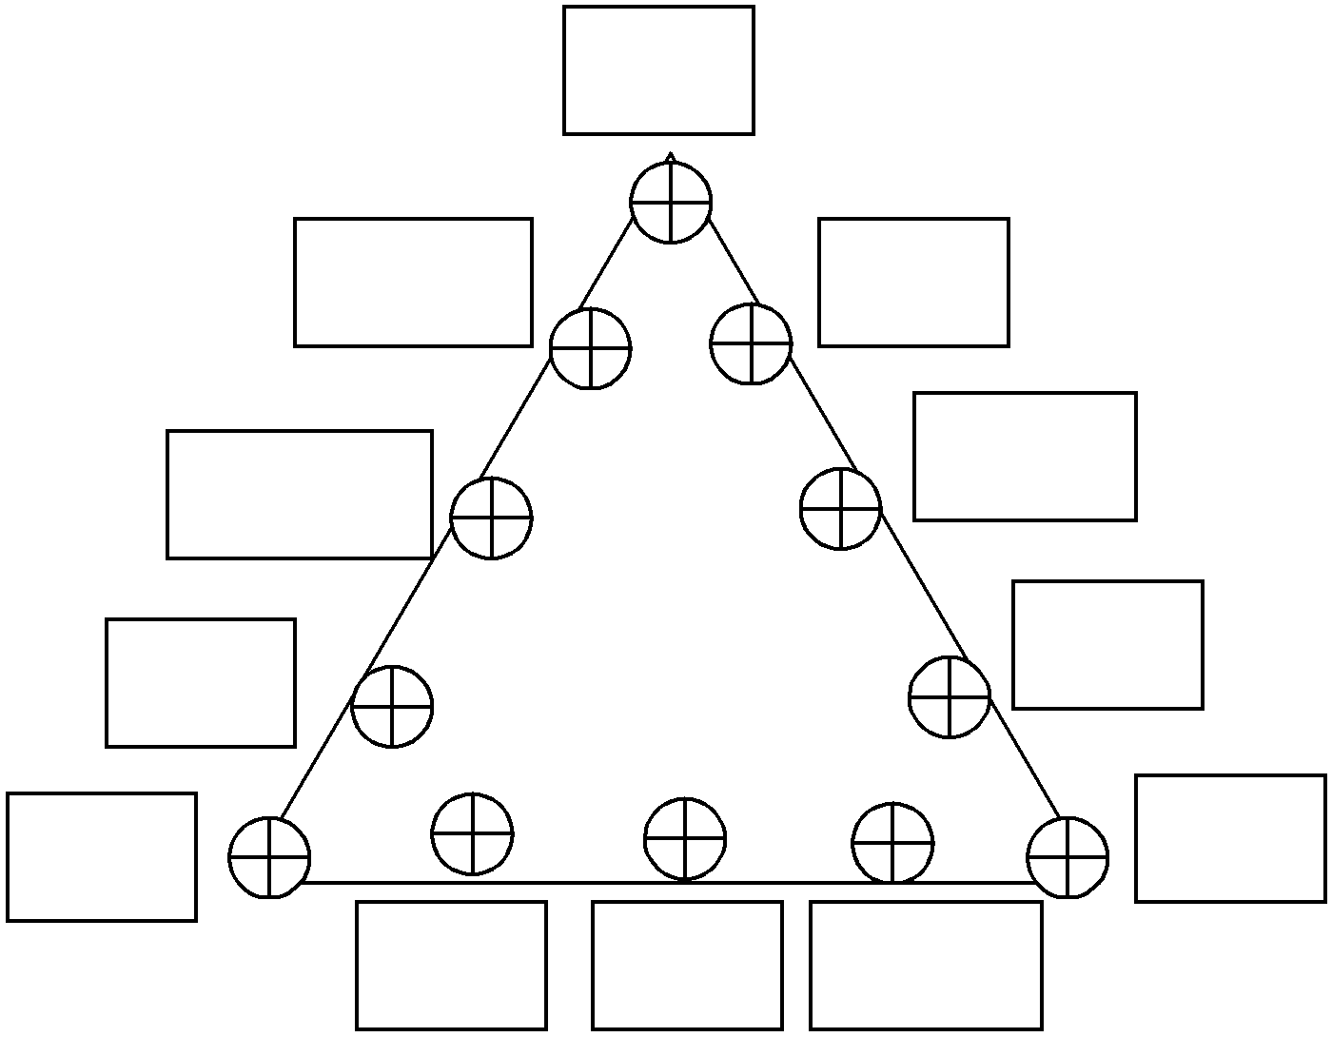
EC

Gen

Treas
SK JW
CG

Rec

SK

SW
W StB
SwB

All Officers and Sir Knights march in. At the command of the Eminent Commander, each Officer walks to his station. All other Sir Knights will sit in the Sidelines with the Ladies and Guests. The Eminent Commander may, at his discretion, move the Pedestal to any other location in the Asylum.
Table

East

Altar
EC

G CG

JW SW

Treas Recor

Pedestal
for Wine
StB SwB

Ward

All Sir Knights, Ladies and Guests will have a seat at the table. No processional. Please assign seats to the Officers prior to having the Christmas Observance. The final seating for appointed Officers will be at the discretion of the Eminent Commander. The above is a suggested seating for the appointed officers. No one should have their backs to the EAST except the Eminent Commander. The Eminent Commander may, at his discretion, move the Pedestal to any other location in the Asylum.

